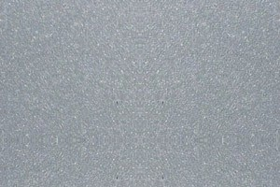

**Aluminium Metallic (M306)**

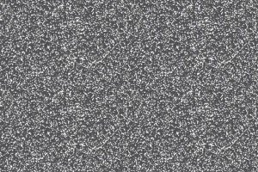

**Antraciet Metallic (M301)**

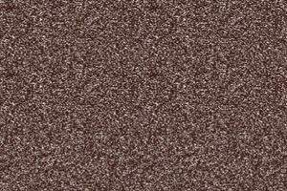

**Bruin metallic (M304)**



**Structuur Wit (S600)**